Running head:  
Scientific Notes

Membership status:  
Members: Xavier Martini (ID 1588)

Billing contact:  
Xavier Martini  
The University of Florida - North Florida Research and Education Center  
155 Research Road  
Quincy, 32351, USA  
Phone: +01 (850) 875-7160  
E-mail: xmartini@ufl.edu  
Include any information (reference number, tax ID, etc.) that you need included on the invoice

**First report of *Phyllocoptes fructiphilus* the vector of the Rose rosette virus in Florida**

Austin **Fife**1*, Sam **Bolton**2, Mathews **Paret**3, and Xavier **Martini**4

1 University of Florida, Department of Entomology and Nematology, Gainesville, Florida, 32611, USA, E-mail: afife@ufl.edu

2 The Florida Department of Agriculture and Consumer Services, Division of Plant Industry, Gainesville, Florida, 32614, USA, E-mail: Samuel.Bolton@FDACS.gov

3 University of Florida, Department of Entomology and Nematology, Gainesville, Florida, 32611, USA, E-mail: paret@ufl.edu

4 University of Florida, Department of Entomology and Nematology, Gainesville, Florida, 32611, USA, E-mail: xmartini@ufl.edu

*Corresponding author; E-mail: xmartini@ufl.edu

*Phyllocoptes fructiphilus* is a microscopic plant-feeding eriophyid mite. *P. fructiphilus* is very host specific, only feeding on plants in the genus *Rosa*, and rarely causes observable damage to their host. *Phyllocoptes fructiphilus* is the vector of the Rose Rosette Virus (RRV). RRV infection is commonly associated with the following symptoms: witches’ brooms/rosetting, deformed flowers, increased prickle density, elongated shoots, reddened leaves and stems, and increased die-back which ultimately kills the rose host. This disease is known as Rose Rosette Disease (RRD) and is the most serious disease of roses, creating millions of dollars of losses for growers. Rose Rosette Disease and the mite have invaded the southeastern united states as they followed the range expansion of the non-native *Rosa multiflora* (Thunb) towards the coast (Amrine Jr 2002, Otero-Colina et al. 2018).

RRD has been detected in Florida in 2014 on 15 plants; however, the plants were destroyed and *P. fructiphilus* were not detected on the roses at that time. (Babu et al. 2014). In 2018 we began a series of surveys along the borders of northern Florida and southern Georgia.

On February 14, 2019, we found a total of 42 eriophyid mites from six samples obtained while surveying roses in Leon County, Florida. (Fig. 1A) The mites were sent to the Florida Department of Agriculture and Consumer Services - Department of Plant Industry (FDACS-DPI) and were all identified as *P. fructiphilus*. The roses did not show signs or symptoms of RDD. These roses were tested for RRV with RT-qPCR and RPA (Babu et al., 2016, 2017). However none of the plants infested with *P. fructiphilus* were positive for RRV.

On July 16th we conducted an additional survey of 33 roses near the initial site of discovery, including the rose sites where *P. fructiphilus* were originally detected. (Fig. 1B), Each sample contained more than 50 eriophyid mites, with some samples containining over 300 mites. We compared the samples collected in February and July with a t-test, and we found a significant increase in *P. fructiphilus* population between the two sampling dates (INCLUDE STATS HERE). These mites all individually plated and subsequently confirmed as *P. fructiphilus*. Additional rose samples were tested for RRV by RT-qPCR, but no virus was detected.

This is the first record for *P. fructiphilus* in Florida. Importantly, RRV is currently not established in Florida. None of the mite-infested roses had symptoms of RRD and none was positive for RRV. However, the presence of *P. fructiphilus*, along with past detections of RRV in Florida warrants increased monitoring for the mite and virus in Florida. History has shown that where the mite has spread the virus follows. There is a critical need to develop methods to manage *P. fructiphilus* and RRV, or the US rose industry stands to lose millions on mite control.

Summary

The invasive mite *Phyllocoptes fructiphilus* (Acari: Trombidiformes, Eriophyidae) feeds on plants in the genus *Rosa* and is known as the primary vector of Rose Rosette Disease (Bunyavirales: Emaraviridae). *Phyllocoptes fructiphilus* is reported for the first time in Florida, USA. No roses showed signs or symptoms of viral infection, and no virus was detected using molecular methods. *Phyllocoptes fructiphilus* represents a potential threat to Florida roses if Rose Rosette Disease becomes introduced.

Resumen

Key Words: Rose Rosette Disease; Rose Rosette Virus; Emaravirus

**References Cited**

**Amrine Jr, J. W.** **2002**. *Rosa multiflora*. Biological control of invasive plants in the Eastern United States. 265–292.

**Babu, B., H. Dankers, E. Newberry, C. Baker, T. Schubert, G. Knox, and M. Paret**. **2014**. First report of rose rosette virus associated with rose rosette disease infecting knockout roses in Florida. Plant Disease. 98: 1449–1449.

**Babu, B., A. Jeyaprakash, D. Jones, T. S. Schubert, C. Baker, B. K. Washburn, S. H. Miller, K. Poduch, G. W. Knox, F. M. Ochoa-Corona, and M. L. Paret**. **2016**. Development of a rapid, sensitive TaqMan real-time RT-PCR assay for the detection of rose rosette virus using multiple gene targets. Journal of Virological Methods. 235: 41–50.

**Babu, B., B. K. Washburn, T. S. Ertek, S. H. Miller, C. B. Riddle, G. W. Knox, F. M. Ochoa-Corona, J. Olson, Y. Z. Katırcıoğlu, and M. L. Paret**. **2017**. A field based detection method for rose rosette virus using isothermal probe-based reverse transcription-recombinase polymerase amplification assay. Journal of Virological Methods. 247: 81–90.

**Otero-Colina, G., R. Ochoa, J. W. Amrine Jr, J. Hammond, R. Jordan, and G. R. Bauchan**. **2018**. Eriophyoid mites found on healthy and rose rosette diseased roses in the United States. Journal of Environmental Horticulture. 36: 146–153.

Figure captions

Figure 1: Presence of *Phyllocoptes fructiphilus* in Leon County, Florida in (A) February 2019 and (B) July 2019. Orange dots indicate sites sampled which had *P. fructiphilus*. Gray areas indicate previously surveyed areas where no *P. fructiphilus* were found.

Figure 2: Log number of *Phyllocoptes fructiphilus* per rose sample. Samples were taken from sites in Leon County, Florida in February 14 and July 16th, 2019. Asterisks represent significant differences as calculated by pairwise t-tests of the 5 sites tested for *P. fructiphilus* during both months, α = 0.05.

Fig. 1

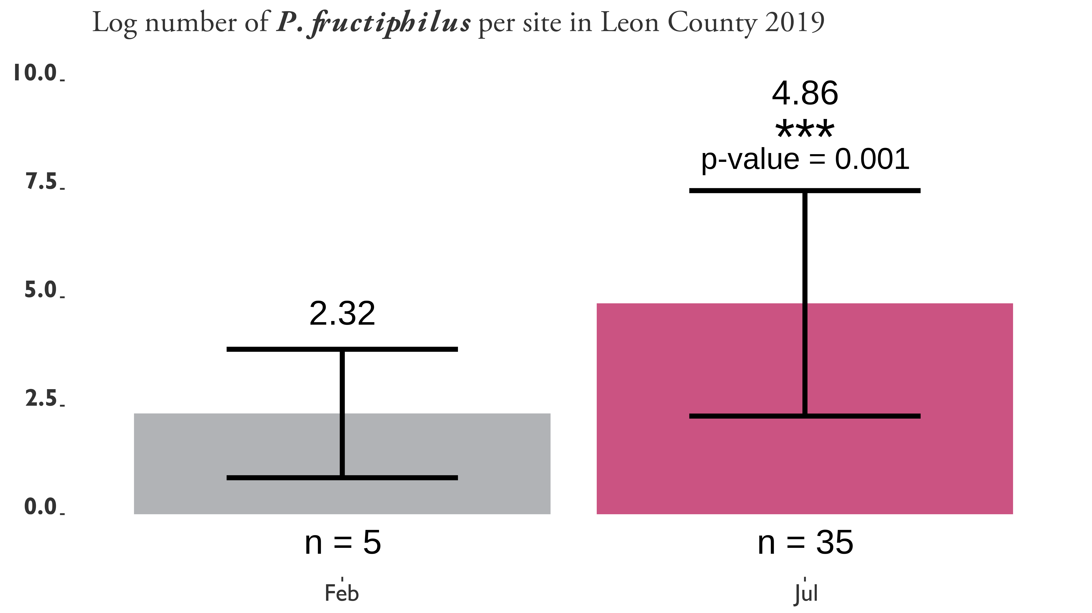

Fig. 2